Equations of Circles Review Problems
To Know:
${\left(x-h\right)}^{2}+{\left(y-k\right)}^{2}=r^{2}$ with center (h,k) and radius r
Midpoint formula $(\frac{x_{1}+x_{2}}{2}.\frac{y_{1}+y_{2}}{2})$ Distance Formula: $d= \sqrt{{\left(x_{1}-x_{2}\right)}^{2}+{\left(y_{1}-y_{2}\right)}^{2}}$

To complete the square: Add ${\left(\frac{b}{2}\right)}^{2}$ where b is the coefficient of the x term to both sides.

I. Writing the equation of a circle given…
1. A graph. Write the equation of graphs A and B on the lines provided below
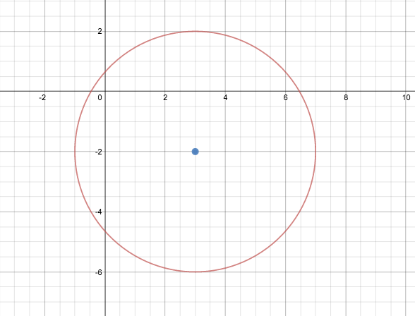
A. B.

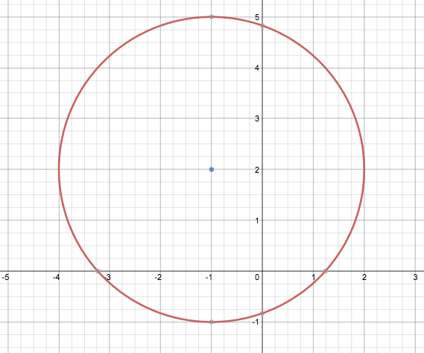

A. ___________________________________________________ B__________________________________________________

2. A center and a radius.
A. Center (-10, -4) ; Radius $3\sqrt{7}$ B. Center (5, -1) ; Radius $4$

A. ___________________________________________________ B__________________________________________________

3. A center and a point
A. Center (3, 2) ; Point (-1,5) B. Center (0, 3) ; Point (4,2)

A. ___________________________________________________ B__________________________________________________

4. Two points on a diameter

A. Points (5,8) and (-5,-2) B. Points (3,2) and (11, 10)

A. ___________________________________________________ B__________________________________________________

5. The center and a circumference. CIRCUMFERENCE FORMULA: $C=2πr$
The circumference of a circle is $10π$ with a center of (-2, -5). Solve for the radius using the circumference formula and then write the equation of the circle.

II. Graphing a circle given its equation.
1. Graph ${\left(x+2\right)}^{2}={\left(y-1\right)}^{2}=36$

III. Changing from general form to standard form by completing the square
.

